Aim: Create a simple web page with headings, paragraphs, lists, and images.
Source Code:
<!DOCTYPE html>
<html>
<head>
<meta charset="utf-8">
<meta name="viewport" content="width=device-width, initial-scale=1">
<title>Types of lists</title>
<style type="text/css">
.mycolor{
color: green;
font-size: 20px;
}
</style>
</head>
<body background="C:\Users\dwive\Downloads\381891.jpg"
style="background-repeat: no-repeat; background-size: cover; opacity: 100;">

<!-- HEADINNG TAGS -->
<h1 style="color: rgb(235, 243, 156);"> Most Important Heading </h1>
<h2>This is heading 2</h2>
<h3>This is heading 3</h3>
<h4>This is heading 4</h4>
<h5>This is heading 5</h5>
<h6>Least Important Heading </h6>
<p>-------------------------------------------------------------------------</p>
<!-- PARAGRAPH TAG -->
<p style="font-size: 20px; ">Computers and programs are everywhere in<br>
today's world. Programs affect many aspects<br> of daily life and
society as a whole. People<br>
depend on programs for communication, shopping,<br>
entertainment, health care, and
countless other needs. </p>
<p>-------------------------------------------------------------------------</p>
<!-- ORDERED AND UNORDERED LISTS -->
<ol>
<li class="mycolor">Html- Structure of a webpage</li>
<li>CSS- Styling and layout</li>
<li>JavaScript- Adds interactivity</li>
</ol>
<ol type="A">
<li>Learn Html basics</li>
<li>Practice CSS styling</li>
<li>Write JavaScript functions</li>
</ol>
<ul>
<li>Input Devices</li>
<li>Output Devices</li>
<li>Storage Devices</li>
</ul>
<dl>
<dt>Hello</dt>
<dd>-World</dd>
</dl>
<p>-------------------------------------------------------------------------</p>
<!-- IMAGE TAG -->
<img src="C:\Users\dwive\Downloads\6440776.jpg";
alt="Image" height="100px" width="100px">
</body>
</html>
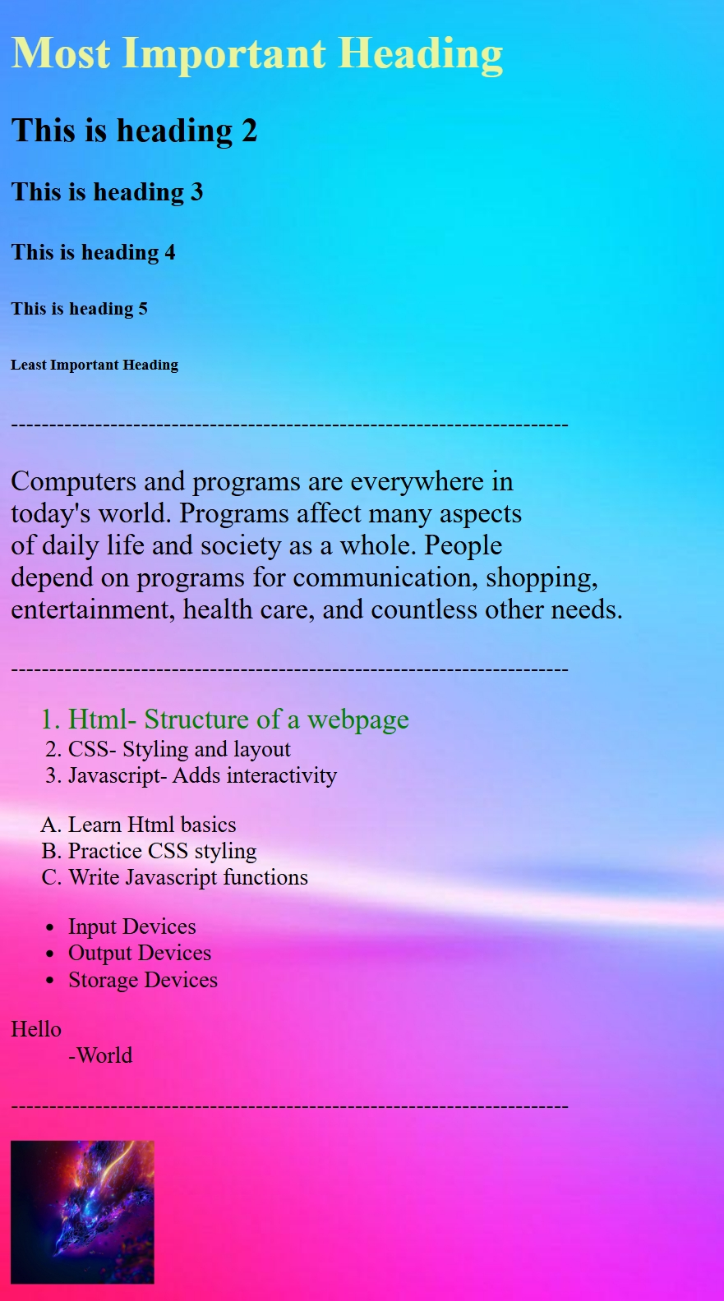
Output:

